How many homes did housing associations deliver in Q3 2024/25?
Briefing note

Summary
- The NHF Supply Data survey shows there was a 1% increase in the number of homes delivered in England in the three months of Q3 2024-2025 compared with the same quarter in 2023. The number of homes started decreased by 23% compared with the same quarter the previous year.

- Housing associations started 6,944 affordable homes on the three months October-December, which is 23% fewer than Quarter 3 of 2023. They completed 10,162 affordable homes, no change on the same quarter the previous year.

- They started 7,131 homes of all tenures (down 23% on the same quarter the previous year) and completed 10,956 (up 1%).

- From the 12 months of 2024, housing associations started 28,010 affordable homes (down 23%) and completed 38,843 (up 1%).

- They started 29,998 homes (down 26%) and completed 42,474 (up 0.4%).

- 2,585 (36%) of all homes started were delivered outside the Affordable Homes Programme in Q3.

- 4,446 (41%) of all homes completed were delivered outside the Affordable Homes Programme in Q3.

- 2,851 (41%) of affordable starts were delivered through Section 106 agreements in Q3.

- 3,809 (35%) of affordable completions were delivered through Section 106 agreements in Q3.

1. Long-term trends
Annual rate of completions by housing associations in England
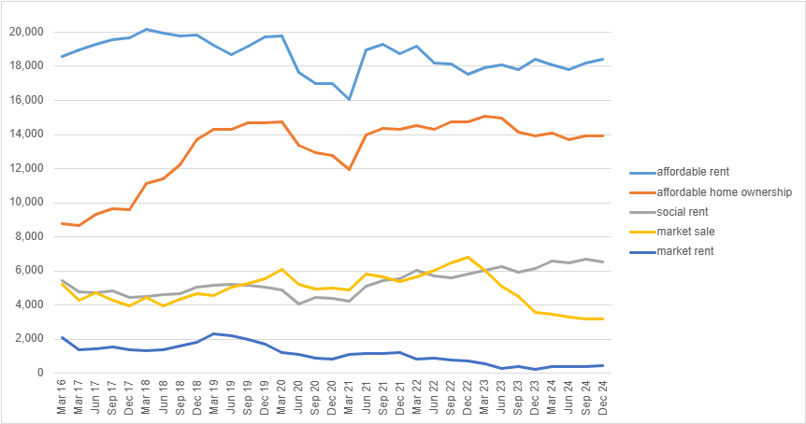
Annual rate = total for the 12 months ended at each date

Annual rate of starts by housing associations in England
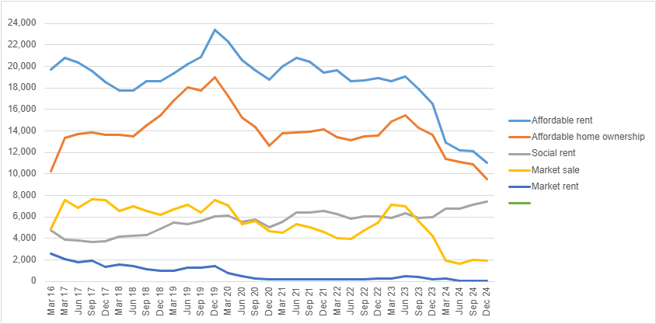
Annual rate = total for the 12 months ended at each date

2. How did we get these results, and why did we do it this way?
- There has been a long-standing problem with the available data on the supply of new housing association homes. The quarterly house building figures published by the Ministry of Housing, Communities and Local Government (MHCLG) acknowledges that the split of data across tenures has limitations and is not the best source of information on new build affordable housing.

- For example, not all the homes delivered for housing associations through Section 106 agreements are attributed to the housing association category.

- However, for results from 2021/22 MHCLG has reviewed and improved its house building data collection so that a larger proportion of Section 106 is attributed to housing associations.

- Other data, published by the Homes England and the Greater London Authority only captures activity within the programmes they fund, so misses out the delivery of homes outside these programmes, whether they are market or sub-market products.

- In order to address these issues, and gain a more complete picture of the level and breadth of development activity engaged in and funded by our members, we collect data on new development of all tenures directly from developing housing associations. This includes affordable homes delivered by the private sector through Section 106 agreements, acquired and owned by housing associations.

- We achieved a response rate of 67%. As such, we believe that this figure will be a small underestimate of the actual total. Survey respondents represent 83% of total stock owned by developing housing associations.

3. Overall tenure breakdown

Table 1: Starts by quarter and tenure type

 | Q2 22/23 | Q3 22/23 | Q4 22/23 | Q1 23/24 | Q2 23/24 | Q3 23/24 | Q4 23/24 | Q1 24/25 | Q2 24/25 | Q3 24/25
Social Rent | 1,560 | 1,664 | 1,789 | 1,337 | 1,140 | 1,703 | 2,562 | 1,331 | 1,507 | 2,024
Affordable Rent | 3,804 | 5,315 | 6,858 | 3,094 | 2,656 | 3,911 | 3,246 | 2,396 | 2,532 | 2,886
Affordable Home Ownership | 3,202 | 4,021 | 5,703 | 2,528 | 2,032 | 3,399 | 3,440 | 2,243 | 1,809 | 2,034
Market Rent | 37 | 205 | 20 | 187 | 1 | 0 | 50 | 0 | 3 | 13
Market Sale | 1,745 | 1,620 | 2,848 | 772 | 400 | 225 | 522 | 478 | 748 | 174
Grand total | 10,348 | 12,825 | 17,218 | 7,918 | 6,229 | 9,238 | 9,820 | 6,448 | 6,599 | 7,131

Table 2: Completions by quarter and tenure type

 | Q2 22/23 | Q3 22/23 | Q4 22/23 | Q1 23/24 | Q2 23/24 | Q3 23/24 | Q4 23/24 | Q1 24/25 | Q2 24/25 | Q3 24/25
Social Rent | 1,563 | 1,612 | 1,854 | 1,254 | 1,201 | 1,865 | 2,239 | 1,179 | 1,397 | 1,692
Affordable Rent | 4,413 | 4,172 | 5,770 | 3,717 | 4,132 | 4,768 | 5,457 | 3,424 | 4,559 | 4,995
Affordable Home Ownership | 3,704 | 3,741 | 4,509 | 2,995 | 2,916 | 3,496 | 4,700 | 2,571 | 3,155 | 3,475
Market Rent | 37 | 218 | 61 | 1 | 94 | 75 | 251 | 0 | 58 | 122
Market Sale | 1,357 | 1,616 | 1,355 | 802 | 732 | 690 | 1,234 | 626 | 667 | 672
Grand total | 11,074 | 11,359 | 13,549 | 8,769 | 9,075 | 10,894 | 13,881 | 7,800 | 9,836 | 10,956

Table 3: Q3 starts by tenure type and programme

 | Inside AHP | Outside AHP | Total
Social Rent | 1,667 | 270 | 2,024
Affordable Rent | 1,347 | 1,279 | 2,886
Affordable Home Ownership | 1,093 | 736 | 2,034
Total affordable | 4,546 | 2,285 | 6,944
Market Rent | - | 13 | 13
Market Sale | - | 174 | 174
Total Market | - | 187 | 187
Grand total | 4,546 | 2,585 | 7,131

Table 4: Q3 completions by tenure type and programme

 | Inside AHP | Outside AHP | Total
Social Rent | 1,007 | 576 | 1,692
Affordable Rent | 2,942 | 1,972 | 4,995
Affordable Home Ownership | 2,395 | 989 | 3,475
Total affordable | 6,510 | 3,652 | 10,162
Market Rent | - | 122 | 122
Market Sale | - | 672 | 672
Total Market | - | 794 | 794
Grand total | 6,510 | 4,446 | 10,956

