


NHF Local Economic Impact Calculator (LEIC): User guide

April 2024
Disclaimer
Whilst every effort has been made to ensure the accuracy of the material in this document, neither Centre for Economics and Business Research Ltd nor the report’s authors will be liable for any loss or damages incurred through the use of the report.
Authorship and acknowledgements
This report has been produced by Cebr, an independent economics and business research consultancy established in 1992. The views expressed herein are those of the authors only and are based upon independent research by them.
The report does not necessarily reflect the views of the NHF.

London, April 2024
Contents
1. Introduction 4
2. Structure of the database 6
3. Worksheet 3: Economic impacts of HA investments in new affordable homes 7
4. Worksheet 4: Economic impacts of Housing Associations’ day-to-day activities 9
5. Worksheet 5: Area profiles 11

Introduction
This is a guide to users of the Local Economic Impacts Calculator (LEIC) that Cebr first constructed in 2013 on behalf of the National Housing Federation.
The point of the LEIC is to allow users (NHF housing association members) to estimate the economic impacts of their:
- investments in new affordable housing; and
- day-to-day activities in managing their existing stocks of housing.
Originally, the database provided impacts at the regional, national and UK level. In 2014, the model was innovated to include a tool that could be used to estimate these impacts at the local authority (LA) and local enterprise partnership (LEP) level.
The LEIC produces impacts at the LA level that are derived on the basis of the HA user’s estimates of the proportion of the different elements of their supply chain that are provided by people or businesses located within the LA or LEP. The higher the percentage of housing investment, for example, that is supported by local goods and services, the greater the likelihood that the multiplier impacts of this investment will be realised within the locality. But it is important to note that goods and services that are not supplied within the local economy are likely to be supplied from other local authority areas, generating multiplier impacts in other parts of the UK.
The 2016 update of the LEIC built in the ability to estimate impacts at the Combined Authority (CA) level. Five CAs were incorporated in 2016. The 2017 update incorporated a further four CAs, including two options for the West Midlands CA – one including constituent LAs only and one including constituents and non-constituents (candidates for inclusion).
The May 2018 refresh of the database was updated to incorporate changes in the make-up of the combined authorities, including the removal of the North East CA and the addition of the new North of Tyne CA and changes in the local authority compositions of some of the others. It also reflected the merging of Northamptonshire LEP with South East Midlands LEP to create the "South East Midlands LEP" featured in the 2018 LEIC.
The April 2019 iteration incorporated minor changes, principally the inclusion of five new Local Authorities within the Sheffield City Region CA and the name change for the Shepway LAD to Folkestone & Hythe. Up to 2018, the models and the estimates of the multiplier impacts they produce, were based on 2010 ONS input-output data. In 2019, the models were updated to use 2013 input-output data.
The refresh from March 2020 incorporated the creation of five new Unitary Authorities. These were East Suffolk (previously Suffolk Coastal and Waveney); West Suffolk (previously Forest Heath and St. Edmundsbury); Bournemouth, Christchurch & Poole (previously three separate local authorities); Dorset Council (previously East Dorset, North Dorset, Purbeck, Weymouth & Portland and West Dorset) and Somerset West & Taunton (previously Taunton Deane and West Somerset).
The principal structural change reflected in the March 2021 update is the creation of a new Unitary Authority: Buckinghamshire (previously Aylesbury Vale, Chiltern, South Bucks, Wycombe). Moreover, a new Combined Authority (North East CA) has been formed and added to the model. These changes have now been fully incorporated into this year’s refresh.
The March 2022 update of LEIC introduced the North Northamptonshire (previously Corby, Kettering, Wellingborough, East Northamptonshire) and West Northamptonshire (previously Daventry, South Northamptonshire, Northampton) Unitary Authorities created at the end of March 2021. This change was partially implemented in Worksheet 5 and fully incorporated into Worksheets 3 and 4. As the raw datasets become consistent, these changes will be gradually incorporated into this worksheet.
For this April 2024 update, there have been no regional or geographic changes. However, one key change relative to the previous 2022 iteration is that although Worksheets 3 and 4 have been updated, Worksheet 5 has not been updated after discussions with the NHF. As such, the results found in this sheet remain the same as they did in the 2022 version of the LEIC.
Pay differential for regions, Combined Authorities and Local Authorities is now compared to England, as opposed to England & Wales in previous versions of LEIC. A small change was also implemented in the calculation of Combined Authority house prices for all years, making them more accurate. For Worksheet 5, local authorities that no longer exist can still be selected to view historical data, they can be found at the bottom of the drop-down list for local authorities.
Finally, for the past two iterations (2021 and 2022) the model had been based on 2015 ONS input-output data. In this 2024 iteration, the models have been updated to use 2019 figures, the latest input-output data available.

Structure of the database
The LEIC consists of six worksheets. These are outlined as follows:
- Database information: containing high-level details of the history of the LEIC and its purpose.
- Glossary of data: featuring definitions of the economic, socioeconomic and housing-related indicators that feature in the LEIC.
- Impacts of affordable homes investments: allowing users to estimate the economic impacts of affordable housing schemes that they plan to invest in. Impacts are produced at the level of local authority districts (LADs), local enterprise partnerships (LEPs), combined authorities (CAs), regions and for each of England and the UK as a whole.
- Impact of housing associations: allowing users to estimate the economic impacts of their day-to-day housing association activities required to manage and maintain their existing affordable housing stocks. Again, the LEIC produces impacts at the level of LADs, LEPs, CAs, regions, as well as for England or the UK as a whole.
- Area profiles: providing a wide range of economic, socioeconomic and housing-related data on a specific LAD, LEP, CA or region. It includes a mapping of the economic ‘footprint’ of all HA day-to-day activities, as well as affordable homes investment activities within a particular area.
- Detailed product categories: this is designed to assist LEIC users of worksheets 3 and 4. If users have a supply chain line item that they are not sure about how to treat within the categories into which supply chain expenditures can be broken down in worksheets 3 and 4, they can identify their expenditure stream with a code and description from worksheet 6. It can then be established which of the categories in worksheets 3 and 4 should be used.
Behind these sheets sit over 100 worksheets of detailed data and calculations that support the three key user sheets (worksheets 3, 4 and 5). The following sections provide a guide to the use of each of these key worksheets.

Worksheet 3: Economic impacts of HA investments in new affordable homes
Worksheet 3 allows LEIC users to estimate the economic impacts of their current or planned investments in new affordable housing. Figure 1 shows the user inputs interface of Worksheet 3 for estimating impacts of investments in new affordable homes.
Figure 1: Worksheet 3 – user input interface for estimating impacts of investments in affordable homes
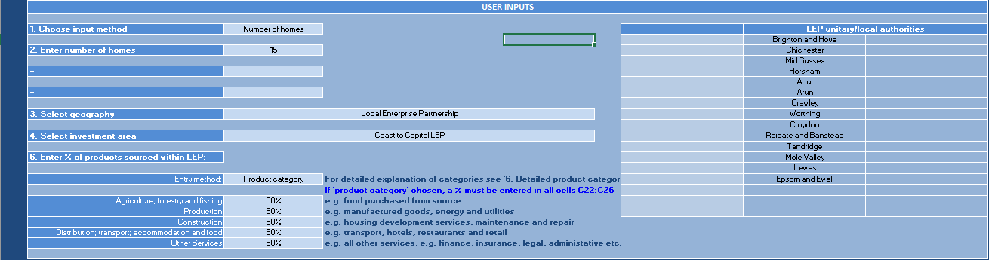
Source: LEIC
To estimate economic impacts, users are required to provide some, or all of the following information:
- Input method – users are required to specify whether they are inputting the total spend under the scheme (“Totals”) or the number of homes to be delivered (“Number of homes”).
- Investment (£) – if the input method is “Totals”, users are required to enter the £ value of the affordable housing investment to be undertaken. If possible, users should provide the breakdown between construction and on costs versus land costs. If this cannot be provided, the database will automatically estimate this breakdown based on regional housing investment data – derived from the Affordable Homes Programmes (AHPs) and the National Affordable Housing Programme (NAHP), which broadly correspond with the shares accounted for by the “works” element of scheme costs under the current SOAHP.
- Number of homes – if the input method is “Number of homes”, users should enter the number of new homes to be built under their scheme. If this option is chosen, the database automatically translates the number of homes into estimates of the value of the investment based on total scheme costs under the current 2016-2021 SOAHP (to end March 2021).
- Geography – users can choose the scope of the area in which they wish to measure the economic impacts of affordable housing schemes. It is possible to choose local authority, LEP, region or Combined Authority.
- Products sourced within LA, LEP or CA – when LA, LEP or CA is selected for the geographic scope of the assessment, users can specify information related to the supply chains that support their schemes. Users can either provide this as an overall percentage of the goods and services sourced within the LA, LEP or CA economy, or can enter individual amounts for five broad categories of input. (More detailed information on what each of these categories include can be found in Worksheet 6: Detailed Product Categories.) The extent to which supplies are sourced from within the LA, LEP or CA area is a key driver of the extent to which the wider multiplier impacts of the HA’s affordable housing scheme remain in the LA, LEP or CA economy. Supplies sourced from outside mean the impacts in the LA, LEP or CA itself will be diluted through leakage to other LAs, LEPs or CAs.
- LA composition of CAs and LEPs: the cells on the right of Figure 1 show the local authority composition of chosen CAs or LEPs, when either is chosen as the geographic scope of a LEIC user’s assessment.
Figure 2 illustrates the modelled outputs. The relevant geographies for the assessment being carried out by the user are confirmed in the first four rows visible in Figure 2. If users have not specified the breakdown between construction and on-costs, on one hand, and land costs on the other, estimates are provided by the database.
The core outputs are the direct impacts and the total impacts tables. Direct impacts are only presented for the local authority and the relevant region. They are the same across the board, so there is no need to repeat for England and the UK. The total impacts include the indirect and induced multiplier impacts associated with investments in affordable homes. The LA-level impacts are driven by user input for products sourced within the LA (or the LEP or CA when either is the chosen geography).
Figure 2: Worksheet 3 – modelled outputs on economic impact of new affordable homes investment
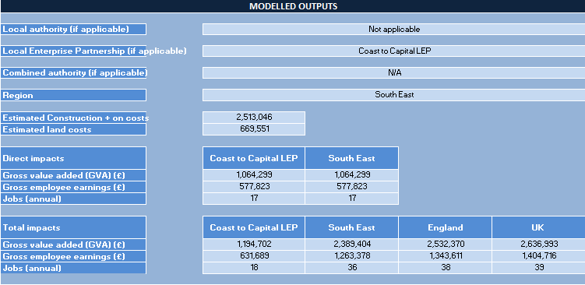
Source: LEIC
The total impacts for the region are driven by the regional multipliers, as detailed in the Methodology Statement supporting the LEIC. Similarly for total impacts in England, which are driven by the estimates of the multipliers associated with affordable homes investments in England, as calculated through our regional input-output models and, again, detailed in the Methodology Statement. The UK-level total impacts are driven by the estimated multiplier for the UK as a whole, as calculated through our UK input-output models.
Direct and total impacts are estimated for three indicators: gross value added (GVA), employee incomes and jobs (for a year).

Worksheet 4: Economic impacts of Housing Associations’ day-to-day activities

This section provides a guide for users of Worksheet 4: Impact of Housing Associations in the LEIC. This allows LEIC users to estimate the economic impacts of their day-to-day activities in managing their existing stock of affordable housing.
Figure 3 shows the user inputs interface of Worksheet 4 for estimating the economic impacts of housing associations and the economic activities involved in renting out, managing and maintaining their existing stocks of affordable housing.
Figure 3: Worksheet 4 – user input interface for estimating impacts of a HA’s day-to-day activities
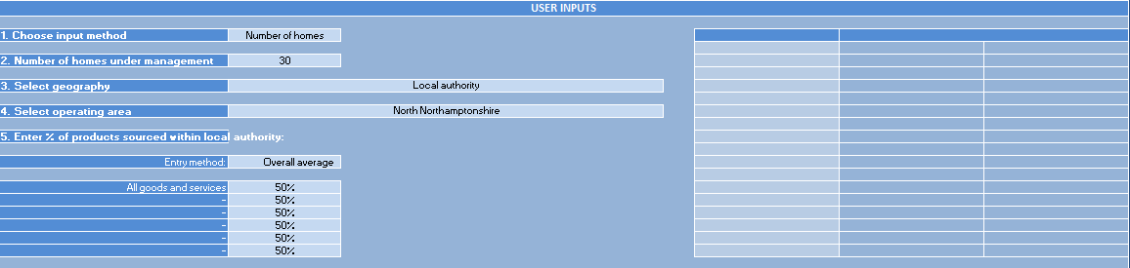
Source: LEIC
To estimate economic impacts, users are required to provide some, or all of the following information:
- Input method – users are required to specify whether they are inputting the total turnover of their HA (“Turnover”) or the number of homes under the HA’s ownership and/or management (“Number of homes”).
- Turnover (£) – if the input method is “Turnover”, users are required to enter the £ value of the turnover of their housing association.
- Number of homes – if the input method is “Number of homes”, users are required to enter the number of homes under the ownership and/or management of their housing association.
- Geography – users can choose the scope of the area in which they wish to measure the economic impacts of their HA’s day-to-day activities. It is possible to choose local authority, LEP, Region or Combined Authority (if applicable).
- Products sourced within LA, LEP or CA – when LA, LEP or CA is selected for the geographic scope of the assessment, users can specify information related to the supply chains that support their HA’s day-to-day activities. Users can either provide this as an overall percentage of the goods and services sourced within the LA, LEP or CA economy, or can enter individual amounts for six broad categories of input. (More detailed information on what each of these six categories include can be found in Worksheet 6: Detailed Product Categories.) The extent to which supplies are sourced from within the LA, LEP or CA area is a key driver of the extent to which the wider multiplier impacts of the scheme remain in the LA, LEP or CA economy. Supplies sourced from outside mean the impacts in the LA, LEP or CA itself will be diluted through leakage to other LAs, LEPs or CAs.
Figure 4 illustrates the modelled outputs in Worksheet 4. The relevant geographies for the assessment being carried out by the user are confirmed in the first three rows visible in Figure 4. If users have chosen “Number of homes” as the input method in the user inputs interface, the LEIC provides an estimate of the corresponding turnover of the HA managing those homes.
The core outputs are the direct impacts and the total impacts tables. Direct impacts are only presented for the local authority and the relevant region. They are the same across the board, so there is no need to repeat for England and the UK. The total impacts include the indirect and induced multiplier impacts associated with the HA’s day-to-day activities. The LA-level impacts are driven by what the user has inputted for products sourced within the LA (or LEP or CA when those geographies are chosen for the geographic scope of the assessment).
Figure 4: Worksheet 4 – modelled outputs on economic impact of housing association day-to-day activities
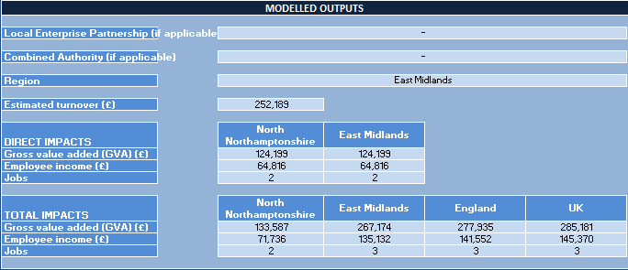
Source: LEIC
The total impacts for the region are driven by the regional multipliers, as detailed in the Methodology Statement supporting the LEIC. Similarly for total impacts in England, which are driven by the estimates of the multipliers associated with the day-to-day activities of HAs in England, as calculated through our regional input-output models and detailed in the Methodology Statement. The UK-level total impacts are driven by the estimated multiplier for the UK as a whole, as calculated through our UK input-output models.
Direct and total impacts are estimated for three indicators: gross value added (GVA), employee incomes and jobs.

Worksheet 5: Area profiles

This section provides a guide for users of Worksheet 5: Area Profiles in the LEIC. This allows LEIC users to examine the activities and economic impacts of all housing associations within a chosen geographic area. The sheet provides a basis for LEIC users to place their outputs from Worksheet 3 or 4 within a wider context of the housing market and economy of the geographic area in which they operate – be that the local authority, local enterprise partnership, combined authority or region.
Note that, following discussions with NHF, Worksheet 5 has not been updated for this iteration of the LEIC. As such, all figures presented are the same as those from the 2022 version of the LEIC.
Figure 5 shows the user inputs interface of Worksheet 5.
Figure 5: Worksheet 5 – Area profiles
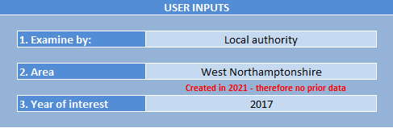
Source: LEIC
To review the profile of an area, users are required to make some simple choices:
- Examine by – users can choose the scope of the area they wish to examine – be that LA, LEP, CA (if applicable) or region.
- Area – once the scope of the area is chosen, users just need to choose the specific LA, LEP, CA or region that they would like to examine.
- Year of interest – the LEIC predominantly includes information dating from 2010 (and in some cases back to 2007) to 2021 and users can choose the year of interest.
Figure 6 illustrates the first set of modelled outputs in Worksheet 5. This includes indicators for the chosen geography, as well as all for the broader geographic area in which it sits. In the illustration, the chosen geography is LA and the specific choice of LA is Liverpool. Indicators are thus provided for the Liverpool LA, the Liverpool City Region LEP, the Liverpool City Region CA, North West region and England as a whole. The indicators include total turnover of all HAs in the relevant geographic area and likewise for employment, housing stock and indicative value of the housing stock.
Figure 6: Worksheet 5 – outputs – Housing Association Activity
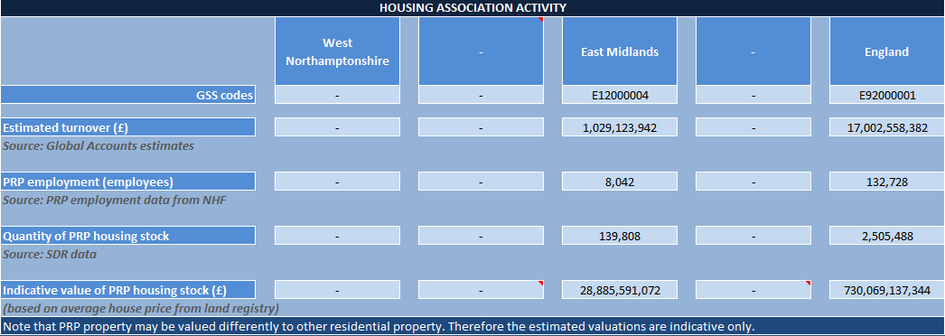
Source: LEIC
Figure 7 illustrates the second set of outputs produced by Worksheet 5. This includes estimates of the economic impacts of the day-to-day activities of all housing associations in the relevant region, in England as a whole and in the UK as a whole. The region for which the outputs are provided corresponds with the user’s choice of area (as in Figure 5 above).
Figure 7: Worksheet 5 – outputs – Economic impacts of housing association day-to-day activities
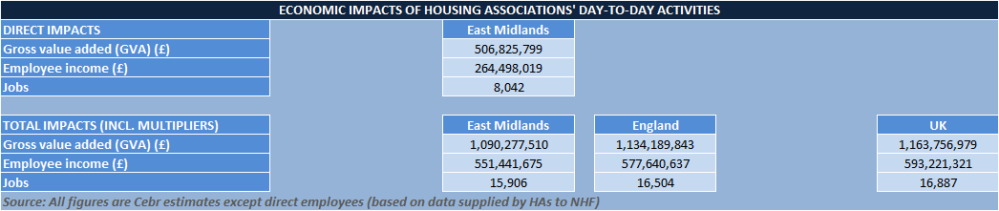
Source: LEIC
Figure 8 shows the location statistics provided by LEIC. This includes details of the broader housing stock, average house prices and average house price differentials and labour market indicators like the unemployment rate, average earnings and earnings differentials.
Figure 8: Worksheet 5 – outputs – location statistics
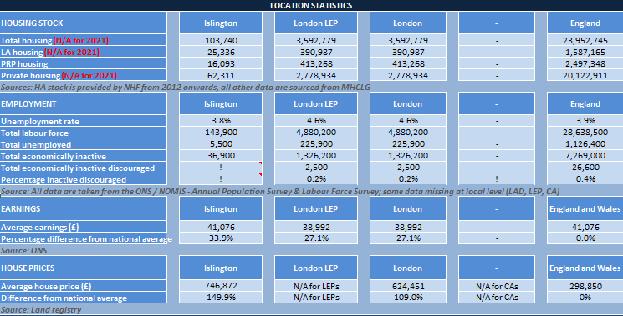
Source: LEIC
Figure 9 below illustrates the final set of outputs from Worksheet 5, which includes the £ values of annual investment in affordable homes and the number of affordable home completions. These data are provided at LA level, CA level and regional level.
Figure 9: Worksheet 5 – outputs – home completions and amounts invested under AHP/SOAHP
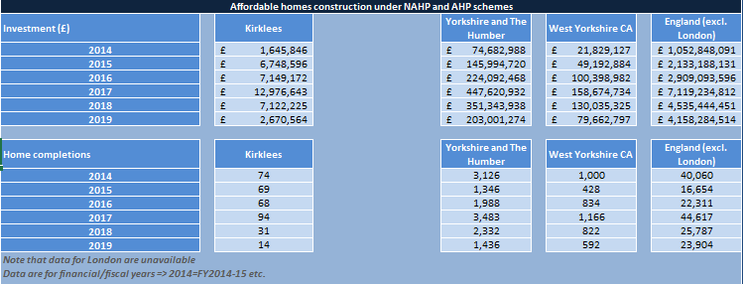
Source: LEIC
Worksheet 5 also provides a set of graphically illustrated time series data for some of the indicators covered in Area Profiles. Samples are provided in Figure 10, Figure 11 and Figure 12 below.
Figure 10: Worksheet 5 – outputs – graphical illustrations of time series data
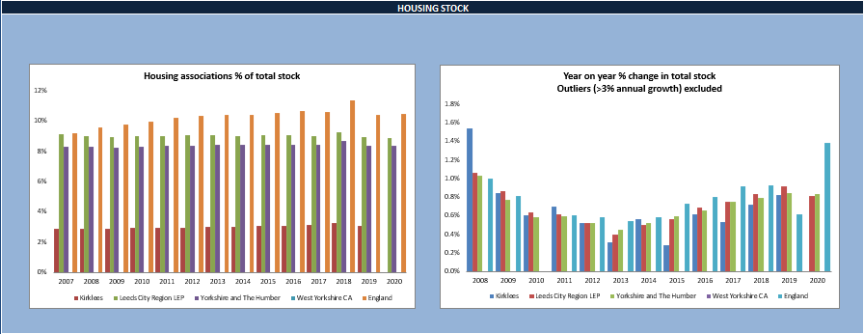
Source: LEIC
Figure 11: Worksheet 5 – outputs – graphical illustrations of time series data
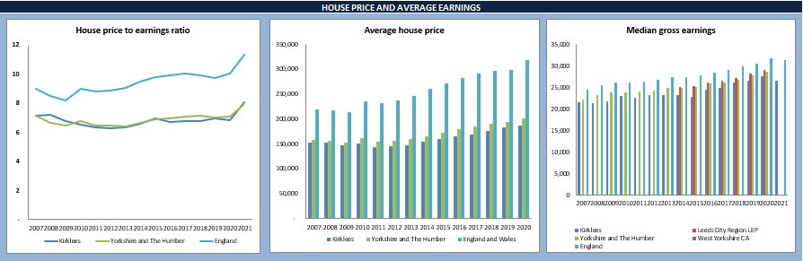
Source: LEIC
Figure 12: Worksheet 5 – outputs – graphical illustrations of time series data
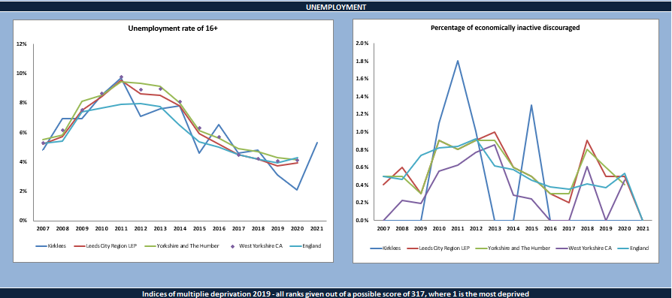
Source: LEIC

Figure 13: Worksheet 5 – outputs – graphical illustrations of time series data
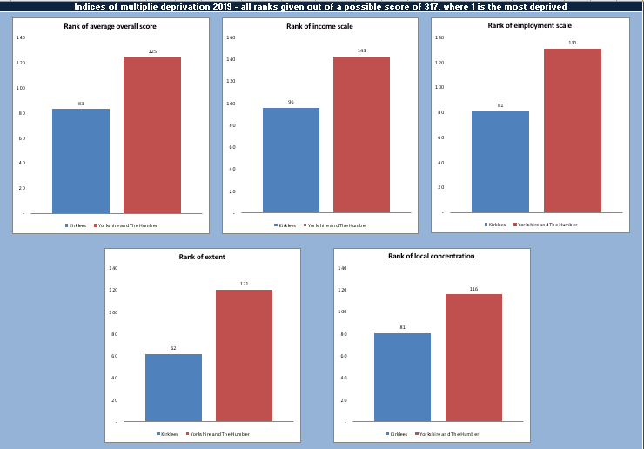
Source: LEIC

Note that LEP was initially introduced to the LEIC under the name “NEW South East Midlands”. The name has since been updated and is simply referred to as “South East Midlands” now.
Note that in this example, because ‘West Northamptonshire’ was only formed in 2021, there exists no prior data to that year – as noted by the message that shows up in red.
Note that although the last year of interest in Worksheet 5 is 2021, the underlying data used within the model which underpins the results in Worksheets 3 and 4 is more recent and goes up to 2023.
Note that 2020 is the latest year for which indices of multiple deprivation are available.

